Function without arguments, without return value: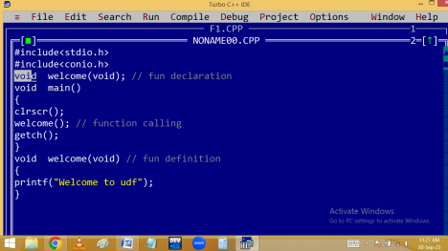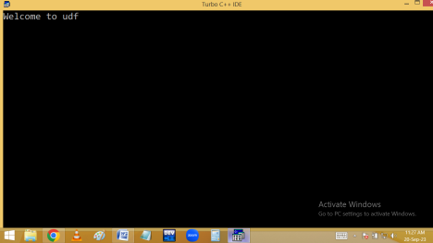
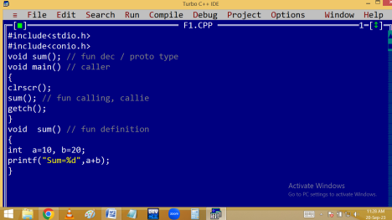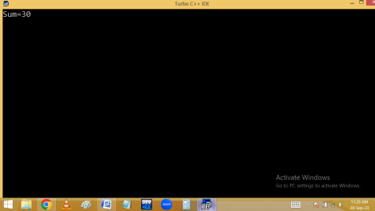Function with arguments, with return value:
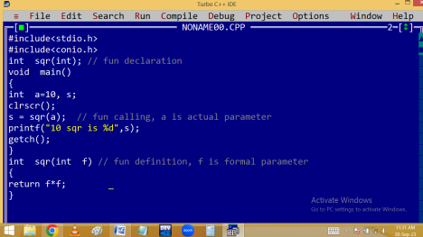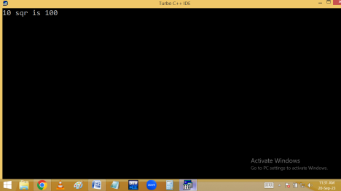
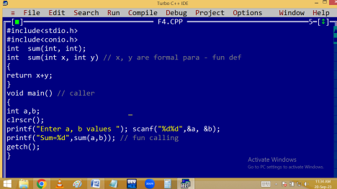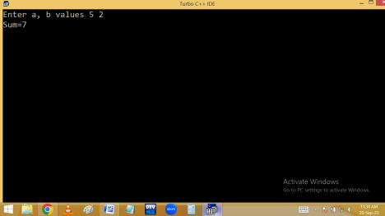Function with arguments, without return value:
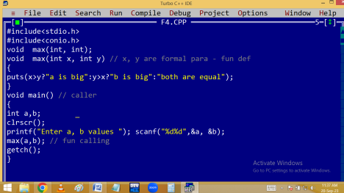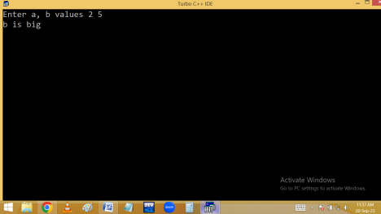
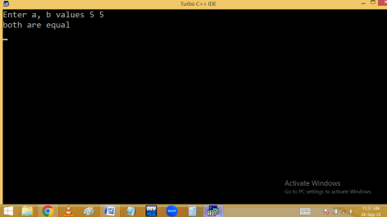
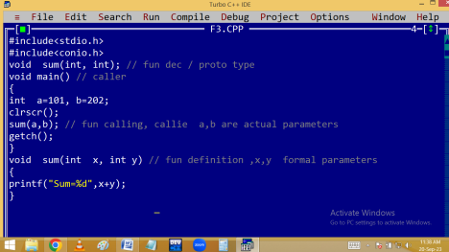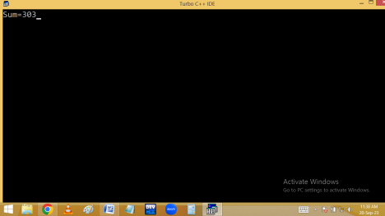
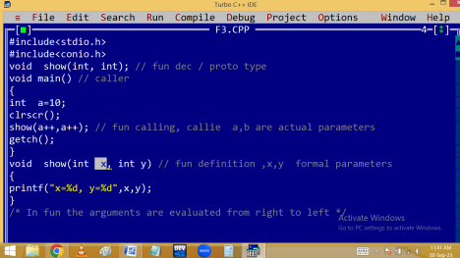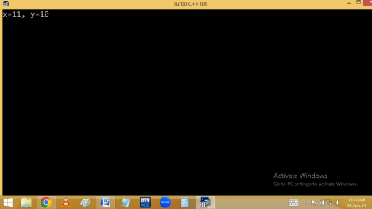Function without arguments, with return value:
Call by value & Address [ reference ]:
Call by address:
Passing parameters to the functions: [parameter passing techniques]
In C-Language, we can send the arguments to the functions in 2 ways.
1. Call by value / pass by value.
2. Call by address / pass by address. [ call by reference ] Call by value / pass by value:
In call by value we are sending actual parameter value to the formal parameter. Later there is no relation is maintained in between actual and formal parameters. Due to this any change in formal parameter doesn’t effects the value of actual parameter.
Eg: 1
#include<stdio.h>
#include<conio.h>
void sqr(int n)
{
n = n * n;
} /* n deleted after the function execution
*/
void main()
{
int a=5;
clrscr();
printf(“Before function call a = %d\n” ,a);
sqr(a); /* fun calling */
printf(“After function call a = %d”, a):
getch();
}
Output:
Before function call a = 5
After function call a = 5
Eg: 2 swapping of two integers
#include<stdio.h>
#include<conio.h>
void swap(int a, int b)
{
int temp=a;
a=b;
b=temp;
}
void main()
{
int a=5, b=7;
clrscr();
printf("Before fun call a=%d, b=%d\n" , a , b);
swap(a, b);
printf("After fun call a=%d, b=%d", a , b);
getch();
}
Output:
Before fun call a=5, b=7
After fun call a=5, b=7
Call by address [Reference]:
In call by address, the address of actual parameter is passed to formal parameter. Due to this the formal parameter should be declared as a pointer. Then only the formal parameter receives the actual parameter address. Due to this any changes in formal parameter effects in actual parameter address i.e. actual parameter value.
Hence pointers allows the local variables to access outside the functions and this process is called call by address / reference.
It is very much useful in handling the strings, arrays etc outside the functions.
Eg: 1
#include<stdio.h>
#include<conio.h>
void sqr(int *n)
{
*n = *n * *n;
}
void main()
{
int a=5;
clrscr();
printf(“Before function call a = %d\n ” ,
a);
sqr(&a); /* fun calling with address */ printf(“After function call a = %d ” , a); getch();
}
Output:
Before function call a = 5
After function call a = 25
Eg: 2 Swap of two integers
#include<stdio.h>
#include<conio.h>
void swap(int *a, int *b)
{
int temp=*a; *a = *b; *b=temp; }
void main()
{
int a=5, b=7;
clrscr();
printf("Before fun call a=%d, b=%d\n", a ,b);
swap(&a, &b);
printf("After fun call a=%d, b=%d", a ,b);
getch();
}
Output:
Before function call a=5, b=7
After function call a=7, b=5
PASSING STRING / ARRAY TO FUNCTION
String/array is implicit pointer i.e. string / array variable stores base address. Due to this when string/array is passed to a function, implicitly base address is passed and formal parameter becomes pointer and it receives this address. Hence any change occurred in formal parameter, effects on actual parameter value also.
We can declare string / array formal parameter in 3 ways.
1. With size eg: char st[50] / int a[3]
2. Without size eg: char st[ ] / int a[ ]
3. As a pointer eg: char * st / int *a
We can pass string / array actual parameter with or without address. Eg:
#include<stdio.h>
#include<conio.h>
#include<string.h>
void reverse( char st[10] ) or st[ ] or *st
{
strrev(st);
}
void main()
{
char s[10]="abcd”;
clrscr();
reverse(s); or reverse(&s);
printf("String = %s", s);
getch();
}
O/P: String = dcba
Passing array to function:
#include<stdio.h>
#include<conio.h>
void show(int a[3]) or a[ ] or *a
{
a[0]=100; a[1]=200; a[2]=300;
}
void main()
{
int a[3]={10,20,30};
clrscr();
show(a); or show(&a);
printf("Array elements %d %d %d",a[0],a[1],a[2]); getch();
}
O/P: Array elements 100 200 300
Passing two – dimensional array to function. #include<stdio.h>
#include<conio.h>
void show( int (*a)[3] ) or a[2][3] or a[ ][3] {
a[0][0]=10; a[1][2]=60;
}
void main()
{
int a[2][3]={1,2,3,4,5,6};
show(a); /* fun calling */
printf("a[0][0]=%d, a[1][2]=%d",a[0][0],a[1][2]); getch();
}
Output: a[0][0]=10, a[1][2]=60;
#include<stdio.h>
#include<conio.h>
void show(int (*a)[3]) /* or a[2][3] or a[][3]*/ {
int r,c;
printf("Elements are\n");
for(r=0;r<2;r++)
{
for(c=0;c<3;c++)
{
printf("%4d",*(*(a+r)+c)); /*or a[r][c]*/ }
printf("\n");
}
}
void main()
{
int a[2][3]={1,2,3,4,5,6};
clrscr();
show(a); /* fun calling */
getch();
}
Function returning address [ pointer ]
Function returning address:

